

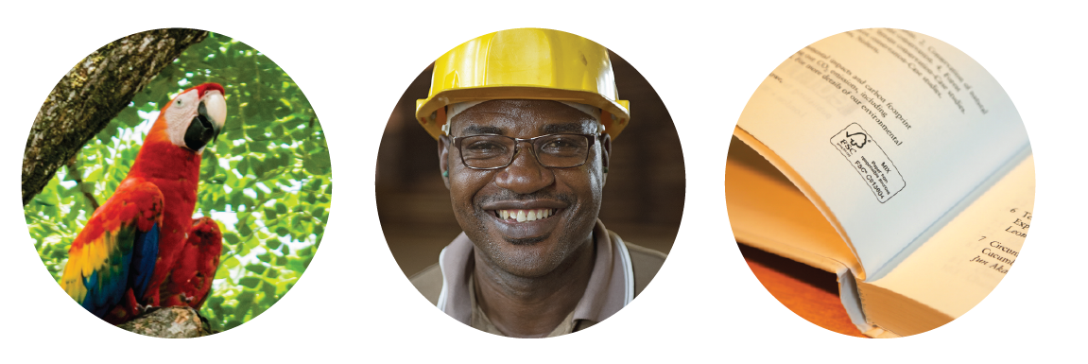

Transaction Verification Procedure

FSC-PRO-10-201 V1-0 - EN

Title: | Transaction Verification Procedure
Document reference code: | FSC-PRO-10-201 V1-0 EN
Approval body: | FSC Director General
Contact for comments: | FSC International Center  -Performance and Standards Unit-  Adenauerallee 134  53113 Bonn, Germany
 |      | +49-(0)228-36766-0  +49-(0)228-36766-30  psu@fsc.org
© 2019 Forest Stewardship Council, A.C. All rights reserved.

No part of this work covered by the publisher’s copyright may be reproduced or copied in any form or by any means (graphic, electronic or mechanical, including photocopying, recording, recording taping, or information retrieval systems) without the written permission of the publisher.

Printed copies of this document are for reference only. Please refer to the electronic copy on the FSC website (ic.fsc.org) to ensure you are referring to the latest version.

TRANSACTION VERIFICATION PROCEDURE

FSC-PRO-10-201 V1-0

The Forest Stewardship Council® (FSC) is an independent, not for profit, non-government organization established to support environmentally appropriate, socially beneficial, and economically viable management of the world's forests.

FSC’s vision is that the world’s forests meet the social, ecological, and economic rights and needs of the present generation without compromising those of future generations.

Contents

  - Objective
  - Scope
  - Effective and validity date
  - References
  - Terms and definitions
  - Version History

  - General Principles
  - Transaction Verification Process
  - Confidentiality and data protection
  - Recording and storing information

Annex 1 Transaction Verification Overview Work Flow

Objective

The objective of this document is to provide a transparent procedure for transaction verification. Transaction verification is one of the certification activities carried out by accredited Certification Bodies and Assurance Services International to safeguard the integrity of the FSC system and address integrity risks in relevant supply chains.

NOTE: This is an operating procedure for transaction verification and as such not part of FSC’s accreditation or certification requirements. It is therefore not subject to the rules and regulations outlined in FSC-PRO-01-001, the procedure for the development and revision of FSC normative documents.

Scope
This document details the procedure to be followed by FSC, ASI, certificate holders and certification bodies for defining, applying (or processing) transaction verification and recording information.

Effective and validity dates

Approval date 22 July 2019

Publication date 22 July 2019

Effective date 22 July 2019

Period of validity Until replaced or withdrawn

References
The following referenced documents are relevant for the application of this document. For undated references, the latest edition of the referenced document (including any amendments) applies.

FSC-STD-20-001 General requirements for accredited certification bodies
FSC-STD-40-004 Chain of Custody Certification
FSC-STD-20-011 Chain of Custody Evaluation
ASI-PRO-20-107 ASI’s Incident Handling Procedure
ASI Data protection FAQs for Transaction Verification (TV)

Terms and definitions

For the purposes of this procedure, the terms and definitions given in FSC-STD-40-004 Chain of Custody, FSC-STD-01-002 Glossary of Terms, and the following apply:

ASI’s Transaction Verification (TV) Tool: an online transaction analysis tool managed by ASI. Transaction data uploaded to the system is automatically matched with other transactions of the specified period in the current transaction verification to identify imbalances in declared volume inputs and outputs.

Falcon: Falcon is an Excel formatting tool which can be used by certificate holders or certification bodies to ensure that transaction verification data is properly formatted. It is locally hosted so does not involve the upload of data into the cloud or outside company firewalls. The transaction data can be entered manually or through a spreadsheet and then Falcon checks to ensure the data is in the proper format, then can be exported in an Excel spreadsheet.

False claim: An FSC claim made on a sales document for products that are not eligible to be sold as FSC certified or FSC Controlled Wood. A false claim is different from an inaccurate claim, in which a product that is eligible to be sold as FSC certified is sold with the wrong claim.

Fraud: The offence of intentionally labelling and/or making FSC claims on sales documents of products that are not eligible to be sold as FSC certified or FSC Controlled Wood.

Fraud gap analysis: a method to identify weaknesses in system controls that are being exploited to commit fraud. The analysis recommends proactive steps to close loopholes in the standard system in order to mitigate fraud risk.

Fraud Risk: a vulnerability an organization faces from individuals capable of committing fraud. The capability is based on a combination of factors including motive, opportunity and ability.

Non-conforming product: product or material for which an organization is unable to demonstrate that it conforms to the applicable FSC certification requirements and eligibility requirements for making FSC claims.

Sample: a ‘sample’ is defined as all transactions in a specified period of time. The sample can include all trading partners or be specific to a product type, product group, species, region, and/or group of customers or suppliers. FSC may pre-determine the type of sample to be taken in a given investigation, which may include instructions on sample size (all or parts of transactions), sampling method (e.g. random, systematic), and if the transactions should be provided in a list of individual transactions or aggregated across the specified period.

Specific Supply Chain: a full or partial supply chain that is identified as high risk on the basis of identified risk of false claims. Indicators of risk include: complaints, wood ID testing results, CB’s reporting of false claims, media reports, the criticality of the issue being publicized, ASI incident reports, and/or ASI monitoring.

Supply Chain Steering Group: approves TV loops for a supply chain based upon evidence of risk and is comprised of the FSC Supply Chain Integrity Director, FSC Technology and Information Unit Director, FSC European Regional Director, FSC Director of Policy Operations, and Chief Operations Officer.

Trading partners: suppliers and customers of the organization for products purchased or sold with FSC claims.

Transaction verification: a method to allow the certification bodies and/or Assurance Services International (ASI) to verify that the certificate holder’s recorded FSC input and output transactions match with the records of their trading partners.

Transaction Verification (TV) Loop: A TV loop refers to the process of TV data collection, analysis, and compliance conducted using the ASI Transaction Verification Tool for a specific supply chain.

Wood Identification Testing: a suite of wood identification technologies used to identify the family, genus, species and origin of solid wood and fibre based products.
Verbal forms for the expression of provisions [Adapted from ISO/IEC Directives Part 2: Rules for the structure and drafting of International Standards]
- “shall”: indicates requirements strictly to be followed in order to conform to the document.
- “should”: indicates that among several possibilities one is recommended as particularly suitable, without mentioning or excluding others, or that a certain course of action is preferred but not necessarily required.
- “may”: indicates a course of action permissible within the limits of the document.
- “can”: is used for statements of possibility and capability, whether material, physical or causal.

Version History

V 1-0: initial version approved by the FSC Director General in July 2019 to clarify how transaction verification is implemented.

General Principles

The selection of a specific supply chain for Transaction Verification (TV) loops by the FSC Supply Chain Steering Group for the purpose of transaction verification is based on the following criteria which determine the risk of false claims (list not exhaustive):

Complaints submitted to the FSC, certification bodies (CBs) and/or ASI;

Wood Identification testing results;

False claims identified during annual audits;

Certification bodies’ reporting of fraud to the FSC database;

ASI or certification bodies’ evaluation reports;

Publicly available information on fraud risks and incidents of fraud;

Analysis of the FSC database; and/or

ASI or FSC incident reports and incident trend data.

The scope of a TV loop is defined by any of the following specifications: identified integrity risks, location, product type, product group, species, primary activity, and/or secondary activity. Other specifications are possible.

A TV loop may include all or part of a specific supply chain from the forest to the retailer and may sample all certificate holders (CHs) in scope or take a sample of those CHs.

Transaction Verification Process
    - The FSC Supply Chain Steering Group shall approve TV loops for a supply chain based upon evidence of risk as specified in Clause 1.1.
    - A TV loop shall be launched at least 30 days prior to the start of the data collection process for CHs.
    - FSC shall announce the TV publicly to CHs when the TV loop has been launched.
    - ASI shall notify applicable CBs via ASI’s Transaction Verification Tool of the decision to implement a TV loop by opening a Transaction Verification Request (TVR) and setting up Certificate in Scope (CS) Records.
    - The CS Record shall include the list of CHs included in the TV loop that are certified by the CB. The CB receives notification of the TVR and CS Records and accesses those records in the ASI TV Tool.
    - CBs shall prepare for data collection within 30 days from the date of the TV loop launch. CBs may request support from ASI and FSC during this period.
    - CBs shall not start data collection during the TV Preparation Phase, which is the time period where ASI and CBs prepare for the specific data collection requirements from CHs.
    - Once the TV Preparation Phase is over, CBs shall notify the CHs and collect samples of transaction data via an Excel spreadsheet template provided by ASI, which is uploaded to the ASI TV tool by the CB.
    - CBs shall complete data collection from certificate holders within 30 days (CH Data Collection Phase).
    - CHs can use the FSC Falcon tool to ensure the formatting of the TV data is correct.
    - The CH shall provide aggregated transactions over the time period indicated in the TVR for each trading partner. ASI may stipulate that volumes shall be aggregated according to other variables as well, including product type and species; so that the certificate holder may report more than one aggregated transaction per trading partner, if there is more than one product or species being traded with that partner.
    - The CH shall provide the following transaction data for each transaction:
- inputs: name of supplier, FSC certificate and license code, aggregate volume over the period, unit of measurement, product type, FSC claim, and species; AND
- outputs: name of customer, FSC certificate and license code, aggregate volume over the period, unit of measurement, product type, FSC claim and species.
    - After the CH Data Collection Phase is complete, CBs shall upload the data collected from certificate holders to the ASI’s TV Tool within 30 days (CB Data Upload Phase).
    - ASI shall issue Corrective Action Requests (CARs) to CBs who do not follow up appropriately with their certificate holders, e.g. by failing to request and collect data from certificate holders, failing to issue NCs to certificate holders when they do not comply with a data request, or by failing to upload the certificate holder data to the ASI’s TV Tool by the deadline at the end of the CB Data Collection Phase.
    - ASI shall analyze mismatches and follow up with CBs after the CB Data Collection Phase is complete. The Data Analysis Phase is approximately 3 months but may be shorter or longer depending on the size of the TV loop (i.e. the number of CHs in the loop). Data analysis may include (but is not limited to) reviewing mismatches, mapping supply chains, and checking on declarations where the certificate holders report no purchases or sales.
    - ASI shall follow up with the CBs via ASI’s TV Tool on mismatches identified through data analysis in a timely manner.
    - ASI may request supporting documents (e.g. invoices) to confirm reported transactions. In this case, ASI shall contact the CBs via ASI’s Transaction Verification Tool.
    - CBs shall inform the CHs, collect the required documents and upload them to the ASI’s TV Tool.
    - CBs shall issue Corrective Action Requests (CARs) to CHs who do not provide the requested data within each specified phase of the TV loop against clause 1.7 in FSC-STD-40-004 V3-0.
    - ASI shall review evidence submitted by CBs and determine if the mismatch is resolved. If the mismatch is demonstrated, ASI shall open an incident handling process and ask the CB to investigate and report back to ASI (per ASI-PRO-20-107 ASI’s Incident Handling Procedure).
    - Once the Data Analysis Phase is complete and all identified integrity risks are reported as incidents, ASI shall provide FSC with the conclusions of the TV loop, as specified in Box 1.

Box 1. Fraud gap analysis

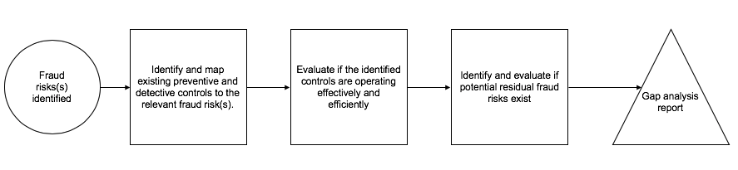

    - ASI shall inform CBs about the outcomes of the TV analysis.
    - FSC will communicate the general conclusions from the TV loop to CHs.

Confidentiality and data protection
    - FSC, ASI and CBs are each responsible to have processes in place for ensuring that personal data and confidential business data collected and taken off-site are processed and protected in compliance with applicable mandatory laws.
    - When non-conformities are identified through Transaction Verification and subsequent ASI investigations, FSC is informed of these non-conformities, including the evidence to support them, so that the appropriate measures can be taken to protect the FSC scheme and FSC’s reputation.

Recording and storing information
    - ASI and CBs each are responsible to have processes in place for recording and determining retention periods of transaction data collected from CHs and this may vary depending on the complexity of the integrity risk(s) identified and the subsequent investigations required.
NOTE: ASI and CBs have complaint mechanisms in place to receive and process any complaints regarding transaction verification.
    - The certificate holder’s transaction data are stored in the ASI’s Transaction Verification Tool with restricted access defined by ASI’s data protection and privacy policies.

Annex 1 - Transaction Verification Overview Work Flow

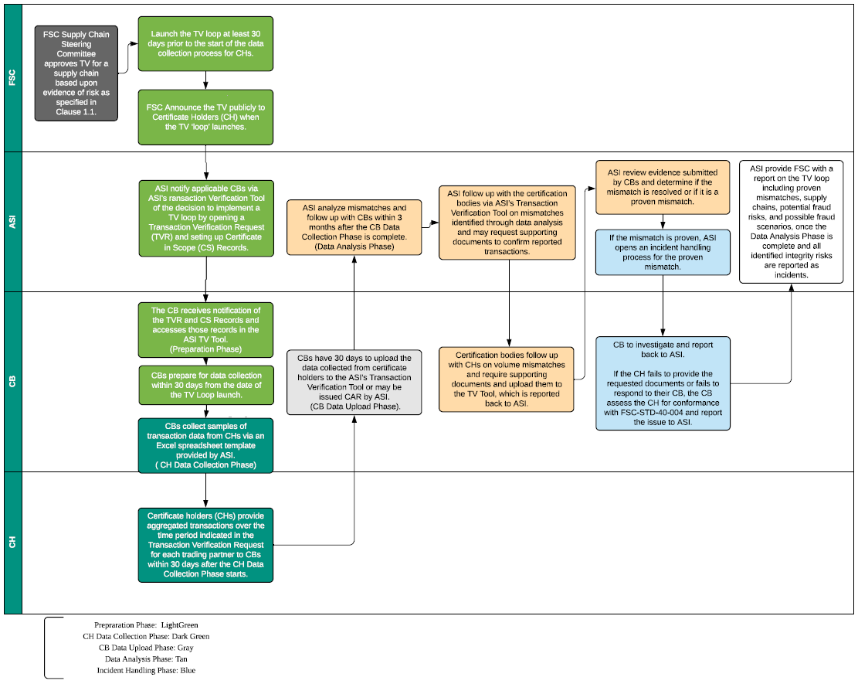

The FSC-STD-20-001 V4-0 General Requirements for FSC accredited certification bodies specifies the accreditation requirements for confidentiality in Section 1.8.

